1. Purpose

This document provides the instruction to setup an OAGIS Repository database. At this time, an implementation is provided for the Oracle Database Management System (DBMS). The installation of the DBMS is out of scope of this document.

2. Requirements

1. Oracle 12c or higher installed. The user executing this database script has sufficient grants to create databases and tables.

2. A database created in the DBMS. In the instruction below, the database name is assumed to be *oagsrt_revision*. If a database has not yet been created, the instruction at [Creating Database](https://docs.oracle.com/database/121/ADMIN/create.htm#ADMIN002) may be useful.

3. Two SQL scripts included in this distribution, one for creating the database schema and the other one for populating data into the database. The script for creating the database schema has the file name *schema-oracle.sql*. The script for populating the data has the file name *data-oracle.sql*.

3. Setting up

Execute the database schema script and then data population script using a DBMS client.

3.1. Example using Oracle SQL Developer

Oracle SQL Developer can be downloaded [here](http://www.oracle.com/technetwork/developer-tools/sql-developer/downloads/index.html).

3.1.1. Create New Connection

If a connection to the desired database, e.g., *oagsrt_revision*, does not exist create one as follows.

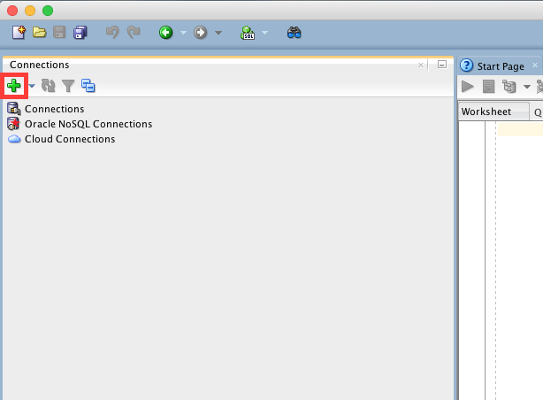

Figure 1. The Home Screen of Oracle SQL Developer

This screen, Figure 1., appeared after Oracle SQL Developer is started. To make new connection configuration, click [+] button on the left-top screen.

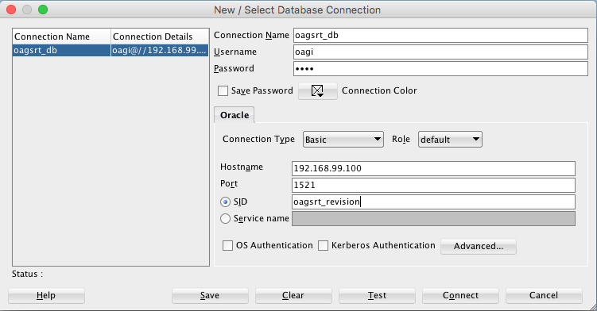

Figure 2. The dialog to create new connection

Fill in a connection name and provide all information to access the database.

In this example, as can be seen in Figure 2., the connection name has been set as *oagsrt_db*, *192.168.99.100* as Hostname, *1521* as Port, *oagi* as Username and *oagsrt_revision* as SID (this is the database prepared earlier). These parameters shall be set based on your environments. Click the *Test* button to check that all connection parameters work. Click the *Save* button so that the connection is available for later user. Then click the *Connect* button to connect to the database.

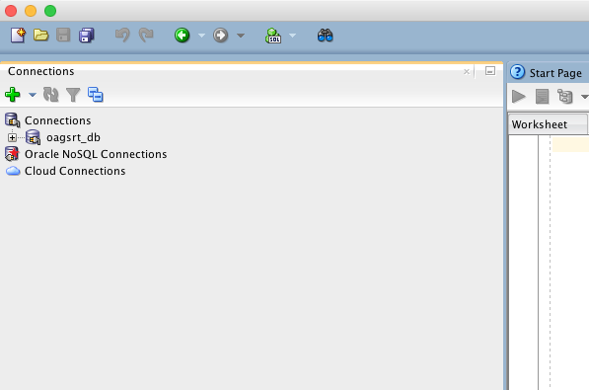

Figure 3. After creating new connection

Now, the database can be accessed. Click the box showing the database connection name created earlier. A Worksheet will display as shown in Figure 4.

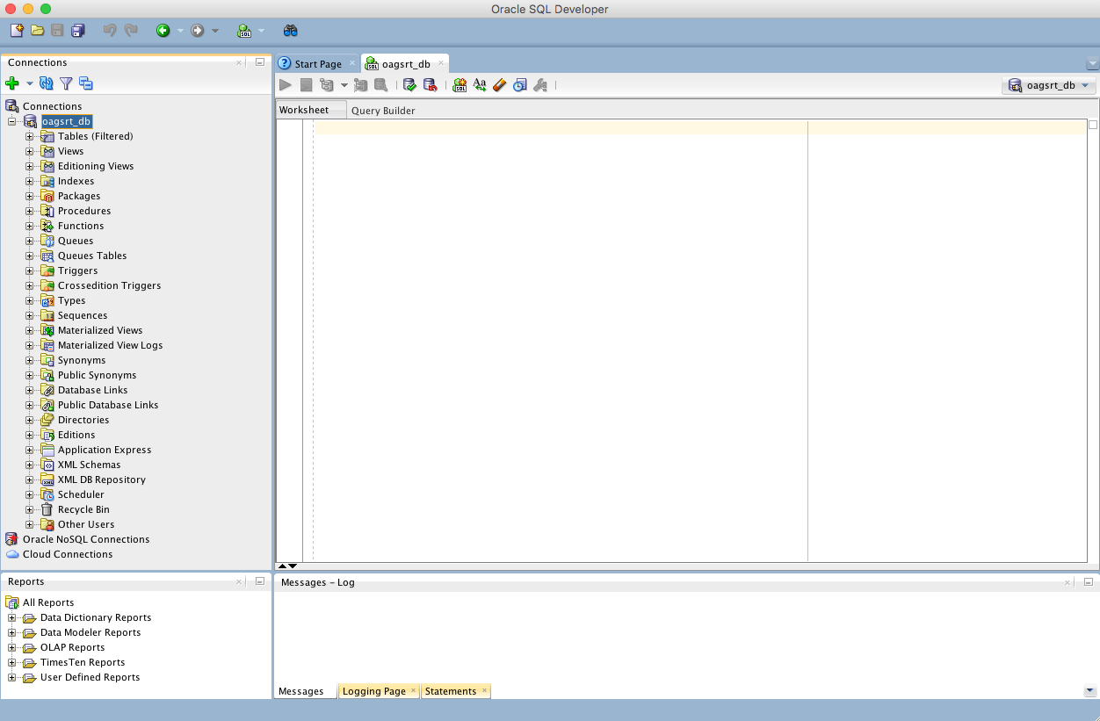

Figure 4. Worksheet on Oracle SQL Developer

3.1.2. Create Schema and Import Data

To create the OAGIS Repository schema and Import data, use the *Open* sub-menu under the *File* menu.

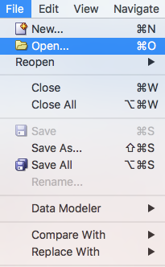

Figure 5. *Open* sub-menu under the *File* Menu

Click this menu and choose ***schema-oracle.sql*** file from your local filesystem. The script is loaded onto the worksheet as shown in Figure 6.

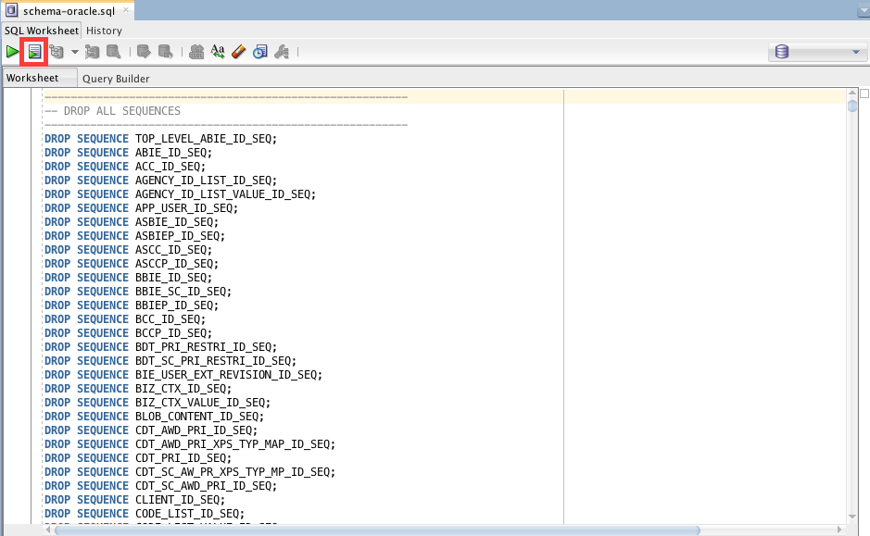

Figure 6. The worksheet before running the schema creation script

Finally, click the ‘Run Script’ button highlighted in Figure 6. Figure 7 shows the result after running the script.

You may receive a Prompt for the connection to that Database. This is where you should select the connection you made earlier. Choose: *oagsrt_db,* and hit the enter key.

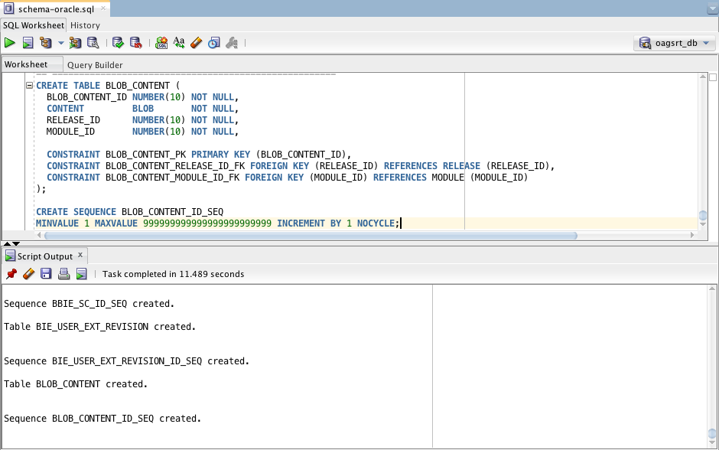

Figure 7. The worksheet after running the script

Upon successful execution, you can see the tables in the selected default schema (database). Click on the Tables tree node as illustrated in Figure 8.

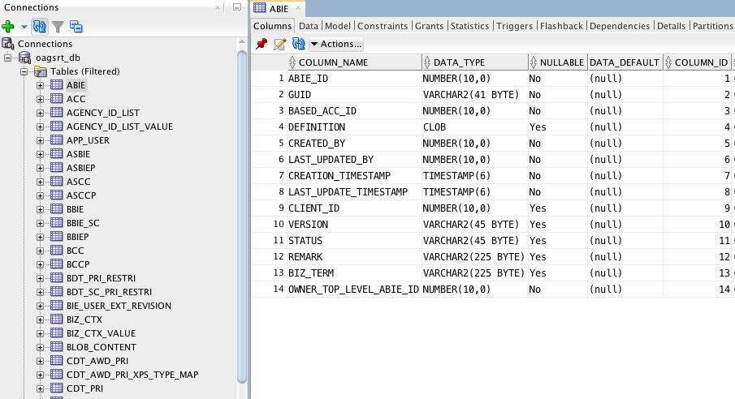

Figure 8. The tables creating by the script

Finally, the data can be imported using the ***data-oracle.sql*** script in the same way.

You may receive a Prompt for the connection to that Database. This is where you should select the connection you made earlier. Choose: *oagsrt_db,* next hit the enter key.

Upon successful import of the data, use the worksheet to execute queries as so desire. See example queries in the included ***ExampleQuery.sql***.